Sri Sathya Sai Palliative Care Center - Puttaparthi
Nurses Notes, Date: Patient ID:
Item | 8AM to 2PM, Nurse: |  | 2AM to 8PM, Nurse: |  | 8PM to 8AM, Nurse:
Pain | Site:  Type:  Score:  Rx: | 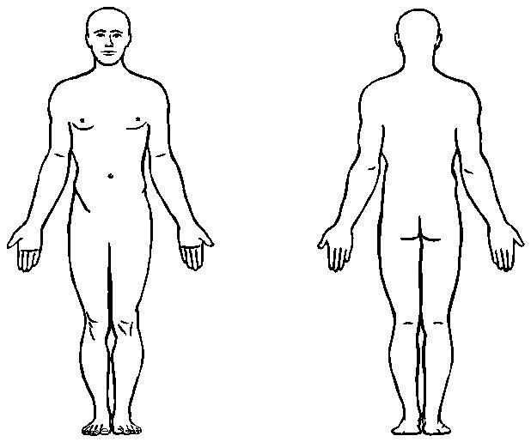 | Site:  Type:  Score:  Rx: |  | Site:  Type:  Score:  Rx:
Bowel
Bladder
Dyspnea
PPS%
Activity
Delirium
Oral Exam
Wound
Bed Sore
Sleep
Vomiting
Opioid Type
Rx Checking
Vitals | BP: PR: RR:  Temp: SPO2: |  | BP: PR: RR:  Temp: SPO2: |  | BP: PR: RR:  Temp: SPO2:

